**THE SOCIETY FOR CASE RESEARCH**



**Inventory Management at the Theme Park**

# Matthew VanSchenkhof, University of Central Missouri David Baker, Tennessee State University

**Jessica Cox, University of Central Missouri**

*This critical incident was prepared by the authors and is intended to be used as a basis for class discussion. The views presented here are those of the authors and do not necessarily reflect the views of the Society for Case Research. The names of individuals and firm have been disguised to preserve anonymity. Copyright © 2015 by the Society for Case Research and the authors. No part of this work may be reproduced or used in any form or by any means without the written permission of the Society for Case Research.*

# Introduction

“*What the . . . ? How can I make sure catering has the right products in the right amounts to make sure we satisfy our customers? Why can’t the warehouse get my order right?”* Erin, a catering supervisor for a Midwest theme park had just audited a warehouse delivery to the catering kitchen. The order was submitted on Monday to be delivered on Wednesday and only half of the order was in front of her. She was expected to feed 18,000 people on Thursday and Friday and she wasn’t sure she’d get what she needed to do so. “*Well, at least I’ll get a good summer project out of this!,”* she thought as she headed to the warehouse to investigate whether the submitted order sheet was correct.

# Background

Erin worked for a 235-acre amusement park located in Kansas City, Missouri. The park was divided into five major sections that included ten counter-service full menu operations, twelve specialty foods (i.e., ice cream, coffee, etc.), and twelve single item food vendors (i.e., Dippin Dots, soda, etc.). The park also operated a full-service catering operation capable of handling more than 8,000 guests per day and generated more than $1.7 million in sales over the summer.

Erin was a 27 year-old junior in a hospitality program at a regional university. Erin was hired into one of three supervisor positions in the catering department. The department had more than forty employees ranging in age from 14 to 18. A non-traditional student, Erin had a few years of broad supervisory experience focused on managing the procurement and production within various foodservice entities, but little food-handling experience. She was ServSafe food safety certified and had completed more than 20 credit hours of hospitality and management classes. She took on the position as catering supervisor to fulfill an internship requirement.

# Warehouse Requisitions

Erin’s training included all the required pieces including basic state and federal laws. The following week she trained with the foods department covering procedures and tasks including

the catering department process for calculating inventory, ordering, and forecasting customer’s food and beverage needs. This was based on how they had been performed in the past.

The catering procurement and production timeline was as follows:

1. Seven days prior to an ordered event a catering supervisor would forecast food needs based on an event’s menu and expected number of participants.
2. Department inventory occurred on Monday and Thursday mornings to determine what product was on hand and what needed to be ordered for the upcoming events.
3. The food order was placed by noon, two days prior to the expected delivery. This was noon on Mondays and noon on Thursdays.
4. Food order deliveries would occur before 10:30 a.m. on Wednesdays and Saturdays. The orders were audited to make sure everything that was ordered was delivered.
5. Any shorted (not enough) products or miss-picks (wrong products) were immediately reported to the warehouse with a “hot shot” order via phone. The “hot shot” detailed what the food item was, where it was to be delivered, and quantity needed.
6. Delivery of “hot shot” orders would occur within four hours, if at all. This often impacted the catering department’s ability to correctly finish events and impacted customer satisfaction.

# Catering Operations

Within a few days of working within the catering operations, Erin noticed there was a consistent problem with the amount of food the kitchen had on hand versus the number of guests in attendance. There were occasions when there was more food available than necessary and other times when severe shortages occurred. Erin investigated whether she and the other supervisors were ordering the correct items in the correct amounts. She found that the orders were usually right and when they were off it was because the other supervisors were over-ordering. The other supervisors stated that they wanted to make sure enough product was on hand.

Whenever there was a shortage, Erin or one of the other supervisors had to call the warehouse to request the inventory item via a form called a “hot shot.” Unfortunately, shortage errors directly impacted the catering departments’ ability to satisfy customer needs, created additional labor costs, caused staff to pillage from other upcoming orders, and led to staff attempting to find suitable substitutes based on extra items they had in stock.

# Warehouse Operations

On a day the weather was bad and all of the park’s picnics were cancelled, Erin seized the opportunity to spend the day in the warehouse attempting to understand why deliveries were so inconsistent. Since the theme park had several food service and retail locations, all food and retail items were delivered to a central warehouse and then distributed to the stores within the park. The warehouse ordered and received food and beverage deliveries from outside suppliers and would then deliver what each shop supervisor turned in on an order slip when food was needed at individual shops. The process is found within Figure 1.

All orders from foodservices within the park were completed in paper form. When Erin or another supervisor completed an order slip and delivered the request to warehouse employees, it was added to a stack of slips from every food location in the park. Warehouse employees grabbed items from multiple order slips and attempted to fill multiple orders at once. Because they also

delivered orders while the park was in full operation, they received phone calls from supervisors who needed hot shot orders. Sometimes these were due to locations not receiving their food requests. These hot shot orders were added to the regular order requests.

Once the items left the warehouse, the “hot shot” form was marked with the total number of items that left the warehouse. However, when the warehouse employees returned and continued with the order requests they marked the items that they had just delivered using the “hot shot” as also being delivered on a regular order. “hot shot” items were being double counted.

# Figure 1: Requisition process for warehouse.

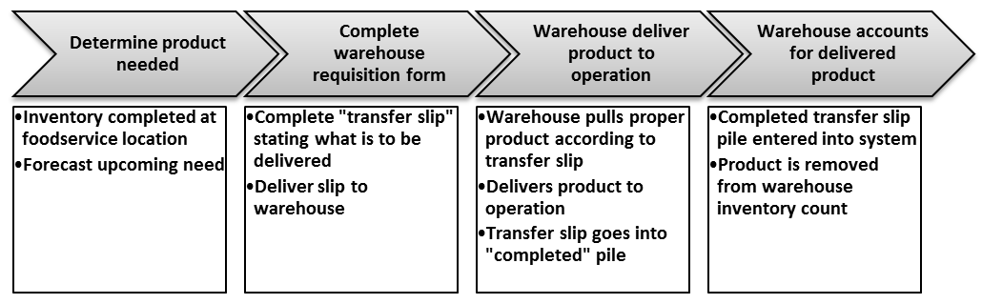

*This figure illustrates the warehouse delivery process.*

Once deliveries were completed, the forms were turned into warehouse supervisors. The supervisors took the paper forms and manually accounted for the items from the warehouse to the shop location. This action removed product from warehouse inventory and added it to the location’s inventory. However, the documentation completed by warehouse employees seemed to show that they were moving almost double the amount of items from their inventory into the location. This documentation flaw left overages when the warehouse attempted to complete an inventory.

Erin immediately noticed the double counting issue. She also saw that several items she had requested and received were marked as not delivered on the order sheets. Others did not account for the additional items which were delivered. She discussed her observations with her instructors. They agreed that the effectiveness of the warehouse processes were limited and negatively impacted aspects of foodservice operations. Her instructors suggested approaching the warehouse issues from a best practices perspective and proposed the following questions to her:

* 1. Was each product being handled too many times?
  2. Was paper the best format to requisition warehouse items?
  3. Could the process be changed to increase order consistency?
  4. How did each area account for the excess food delivered?

Erin was required to discuss and offer potential solutions to an issue within her internship. The warehouse issue might be perfect for her. Erin thought: “*JEEZ! Well, at least I’ll get a good summer project out of this!”*